Functional Decomposition Block Diagrams

**Level 0: Systems Overview**

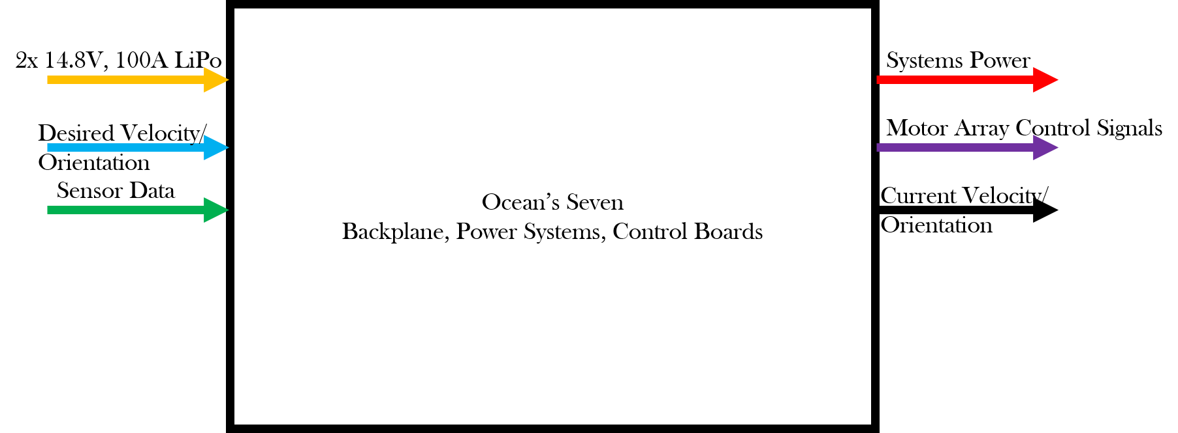

|  |  |
| --- | --- |
| Module | Backplane, Powers and Controls systems |
| Inputs | * 2x 14.8V 100A LiPo: External Power provided by two lithium ion polymer batteries. * Desired velocity/orientation: Orientation and velocity information provided by the CPU based current location and desired location * Sensor Data: IMU and DVL data to determine relative position, acceleration and velocity vectors. |
| Outputs | * Systems Power: 3.3V, 5V, 12V, 14.8V, 19V, 48V requirements to maintain power to all systems on the AUV * Motor Array Control Signals: PWM or I2C signals provided to the ESCs to regulate individual motor torques. * Current Velocity/Orientation: Relative position, orientation, and velocity vectors for use by the CPU to make decision |
| Functionality | The backplane, power systems and controls boards are responsible for providing reliable power to all components in the AUV, vehicle stability and maneuvering, and standardizing connection of additional unspecified components |
| Sub Modules | * Backplane * Power Board * Controls Board |

Level 1: Module Overview

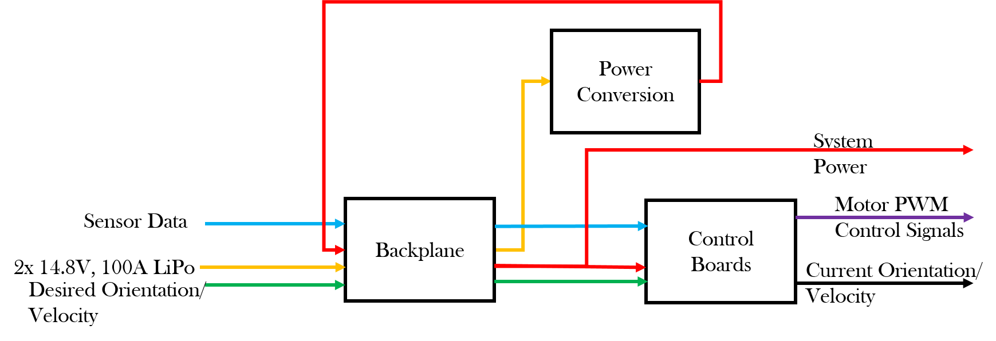

|  |  |
| --- | --- |
| Module | Backplane |
| Inputs | * 2x 14.8V 100A LiPo: External Power provided by two lithium ion polymer batteries. * Desired velocity/orientation: Orientation and velocity information provided by the CPU based current location and desired location * Sensor Data: IMU and DVL data to determine relative position, acceleration and velocity vectors. * Systems Power: 3.3V, 5V, 12V, 14.8V, 19V, 48V requirements |
| Outputs | * 2x 14.8V 100A LiPo: External Power provided by two lithium ion polymer batteries. * Desired velocity/orientation: Orientation and velocity information provided by the CPU based current location and desired location * Sensor Data: IMU and DVL data to determine relative position, acceleration and velocity vectors. * Systems Power: 3.3V, 5V, 12V, 14.8V, 19V, 48V requirements |
| Functionality | The backplane is responsible for efficiently routing all power and communications requirements throughout the AUV. |
| Sub modules | * 2x Auxiliary boards * 1x central distribution board |

|  |  |
| --- | --- |
| Module | Power Conversion Board |
| Inputs | * 2x 14.8V 100A LiPo: External Power provided by two lithium ion polymer batteries. |
| Outputs | * Systems Power: 3.3V, 5V, 12V, 19V, 48V requirements |
| Functionality | The power conversion board is responsible for taking the 14.8V system power and converting it to the required voltage requirements for the AUV |
| Sub Modules | * DC-DC Switching Converters 14.8V to: 3.3V, 5V, 12V * DC-DC Boost Converters 14.8V to: 19V, 48V * Physical or optical isolation for 19V line |

|  |  |
| --- | --- |
| Module | Controls Board |
| Inputs | * Power: 3.3V and 5V lines * Desired velocity/orientation: Orientation and velocity information provided by the CPU based current location and desired location * Sensor Data: IMU and DVL data to determine relative position, acceleration and velocity vectors. |
| Outputs | * Motor Array Control Signals: PWM or I2C signals provided to the ESCs to regulate individual motor torques. * Current Velocity/Orientation: Relative position, orientation, and velocity vectors for use by the CPU to make decision |
| Functionality | The controls board is responsible for handling the computations required to provide stable maneuvering of the AUV given directions provided by the AUV CPU |
| Sub Modules | Ethernet, STM32F767VIT, USB, JTAG |

Level 2

Controls Systems Board

Controls FD2.png

|  |  |
| --- | --- |
| Module | Ethernet Socket |
| Inputs | DVL Data |
| Outputs | Current position/velocity vectors |
| Functionality | Receive data from the DVL over an ethernet line and convert it to readable information for the STM32F767VIT |
| Submodules | N/A |

|  |  |
| --- | --- |
| Module | FTD232 |
| Inputs | USB Data |
| Outputs | RS232 Data |
| Functionality | Convert USB data signal into RS232 |
| Submodules | N/A |

|  |  |
| --- | --- |
| Module | JTAG Programmer |
| Inputs | Programming, debugging signals |
| outputs | Operating system onto STM32F767VIT |
| Functionality | Programming interface for flashing the microcontroller and debugging software |
| Submodules | N/A |

|  |  |
| --- | --- |
| Module | 3.3V linear regulator |
| Inputs | 3.3V-5V |
| Outputs | 3.3V |
| Functionality | Stabilize a 3.3V line for the microcontroller to mitigate issues from voltage fluctuations |
| Submodules | N/A |

|  |  |
| --- | --- |
| Module | STM32F767VIT |
| Inputs | * 3.3V: Main voltage for MCU * Ethernet: DVL Data * IMU Data from I2C * JTAG Programmer: Bootloader/RTOS * FTD232: Desired Velocity/Orientation from CPU |
| Outputs | * 8x Control signals via I2C * Current Position/Velocity via FTD232 -> CPU |
| Functionality | Maintains situational awareness of the AUV and provides stable maneuvering by taking in desired position/velocity vectors from the CPU and running the values through control algorithms |
| Submodules | Software: Serial communication handling, data logging, controls algorithms |

Power Conversion Board

Power FD-L2.png

|  |  |
| --- | --- |
| Module | 14.8V-3.3V DC/DC Switching Converter |
| Inputs | 14.8V: Main system power |
| Outputs | 3.3V: To be used by microcontrollers and sensors. |
| Functionality | Provide stable 3.3V output |
| Submodules | Supporting electrical components |

|  |  |
| --- | --- |
| Module | 14.8V-5V DC/DC Switching Converter |
| Inputs | 14.8V: Main system power |
| Outputs | 5V: To be used by microcontrollers and sensors. |
| Functionality | Provide stable 5V output |
| Submodules | Supporting electrical components |

|  |  |
| --- | --- |
| Module | 14.8V-12V DC/DC Switching Converter |
| Inputs | 14.8V: Main system power |
| Outputs | 12V: To be used by actuators |
| Functionality | Provide stable 12V output |
| Submodules | Supporting electrical components |

|  |  |
| --- | --- |
| Module | 14.8V-19V Boost Converter |
| Inputs | 14.8V: Main system power |
| Outputs | 19V: To be used by the CPU |
| Functionality | Provide Isolated stable 19V output |
| Submodules | Optical Isolator, Supporting electrical components |

|  |  |
| --- | --- |
| Module | 14.8V-48V Boost Converter |
| Inputs | 14.8V: Main system power |
| Outputs | 48V: To be used by the DVL, power over ethernet line |
| Functionality | Provide stable 48V output |
| Submodules | Supporting electrical components |

backplane_fd2.png

|  |  |
| --- | --- |
| Module | Main distribution Board |
| Inputs | * External Power * Systems Power |
| Outputs | * Systems Power * I2C Bus * RS232 Bus * 8x 14.8V, 30A motor traces |
| Functionality | Provide handling of high power lines for motors and act as a central hub for communications and power distribution between the two auxiliary boards |
| Submodules | Current Merge Circuit, Power conversion board connector, external power connector, 8x 4 pin, 30A connector, 2x Board to wire to board connector |

|  |  |
| --- | --- |
| Module | Auxiliary Board |
| Inputs | * Systems Power * I2C Bus * RS232 Bus * Sensor Data |
| Outputs | None |
| Functionality | Provide power and communication connection points for the control system board and other undefined modules in the future. |
| Submodules | Board to wire to board connector, Nx Board to board connectors |

|  |  |
| --- | --- |
| Module | Sensor Suite |
| Inputs | * Translational acceleration * Rotational velocity * Translational velocity * Relative position * Heading, Pitch, Roll |
| Outputs | * Sensor Data |
| Functionality | The sensor suite is comprised of multiple sensors distributed around the AUV, both internally and externally, that maintain situational awareness of the AUV’s position, velocity and acceleration |
| Submodules | 2x IMU, 1x DVL |

**Roles Responsibilities and Components**

Use Cases:

1. System Power Up
2. Normal Operations
3. Kill Switch Activated

|  |  |  |  |
| --- | --- | --- | --- |
| Use Case Reference | Responsibilities | Roles | Hardware Component, Software Component, or Both |
| 1, 2 | Provide voltage and current at required levels to microcontrollers and additional digital components | Buck Conversion to 3.3V at 3A | 14.8V to 3.3V DC buck converter |
| 1, 2 | Provide voltage and current at required levels to IMU’s and ESC PWM lines | Buck Conversion to 5V at 3A | 14.8V to 5V DC buck converter |
| 1,2 | Provide voltage and current at required levels to the actuators | Buck Conversion to 12V at 1A | 14.8V to 12V DC buck converter |
| 1,2 | Provide stable voltage and current to the main computer | Boost Conversion to 19V at 4A | 14.8V to 19V DC boost converter |
| 1,2 | Provide voltage and current to the power over ethernet (POE) downwards facing camera and DVL | Boost Conversion to 48V at 2A | 14.8V to 48V DC boost converter |
| 2 | Maintain stability while maneuvering | Movement Stabilizer | Hardware: 2 IMUs, DVL, 2 Video Ray Pro 4 Thrusters, 6 Blue Robotics T100 Thrusters, MCU  Software: PID or other stability control algorithm implemented on the MCU |
| 2 | Calculate optimal paths from current position, orientation, and velocity to a desired position orientation and velocity | Pathing Calculator | Hardware: 2 IMUs, DVL, 2 Video Ray Pro 4 Thrusters, 6 Blue Robotics T100 Thrusters, MCU    Software: Pathing controls algorithm |
| 2 | Log sensor data for feedback and performance analysis after a run | Sensor and Data Logging | Hardware: 2 IMUs, DVL, RS232 Bus, MCU  Software: Data Logger, Communication Packager, implemented on MCU |
| 1 | Ensure the system powers up in an effective order | Power on Routine | Hardware: MCU  Software: Power up sequence with communication between MCU and main computer |
| 1,2 | Monitor voltages and currents to maintain safe operation | Voltage and Current monitor | Hardware: MCU, Voltage Sensor, Current Sensor  Software: Data log, and automatic shut down |
| 3 | Disable high power traces and motors | Mechanical Kill Switch | Hardware: Read Switch, Power Mosfet |